Table of Contents
Part I. The PNRI SPMS 1
A. Background 1
Mission 1
Vision 1
Mandate 1
Organizational Structure 2
Staffing Summary 2
B. The PNRI SPMS Concept 3
C. General Objectives 3
D. Basic Elements 3
E. Key Players and Responsibilities 4
Part II. The PNRI SPMS Process 7
A. The PNRI SPMS Cycle 7
Stage ❶ Performance Planning and Commitment 7
Stage ❷ Performance Monitoring and Coaching 9
Stage ❸ Performance Review and Evaluation 10
Stage ❹ Performance Rewarding and Development Planning 11
B. Rating Period 12
Rating Scales 12
C. Appeals 14
D. Sanctions 14
E. Uses of Performance Ratings 15
F. Transparency on Performance Ratings 15
G. Effectivity 16
Annex A. Special Order: PNRI-SPMS Performance Management Team 17
Annex B. SPMS Process Flowchart 18
Annex C. SPMS Calendar 19
Annex D. SPMS Communication Plan 20
Annex E. Performance Planning and Commitments 21
Annex F. Success Indicators 23
Annex G. Section Performance and Commitment Review Form 27
Annex H. Individual Performance and Commitment Review Form 28
Annex I. Performance Monitoring and Coaching Journal 29
Annex J. Division Performance Monitoring and Coaching Form 30
Annex K. Individual Performance Monitoring and Coaching Form 31
Annex L. Sample Summary List of Individual Performance Ratings 32
Annex M. Basis of Rating Scale for Quality of R&D Work 33

STRATEGIC PERFORMANCE MANAGEMENT SYSTEM (SPMS)
PHILIPPINE NUCLEAR RESEARCH INSTITUTE (PNRI)

The PNRI SPMS

Background
The Philippine Nuclear Research Institute (PNRI)—formerly the Philippine Atomic Energy Commission (PAEC)—is the center of nuclear science, nuclear technology and nuclear regulatory activities in the country.
In 1958, with the enactment of Republic Act 2067 as amended by Republic Act 3589 known as the Science Act of 1958, the PAEC was created with a dual mandate:
  - Research and development involving atomic energy, special nuclear materials and other radioactive materials; and
  - Regulation and licensing of radioactive materials
The regulatory mandate of PAEC was strengthened further in 1977 with the enactment of Republic Act 5207 known as the Atomic Energy and Liability Act of 1968 as amended by Presidential Decree 1484.
In 1987, under Executive Order 128, the PAEC was reorganized and renamed as the PNRI. It is now one of the research and development institutes of the Department of Science and Technology (DOST) with regulatory and licensing functions.

Mission
“We contribute to the improvement of the quality of Filipino life through the highest standards of nuclear research and development, specialized nuclear services, nuclear technology transfer and effective and efficient implementation of nuclear safety practices and regulations.”

Vision
The PNRI is an institution of excellence in nuclear science and technology propelled by a dynamic and committed workforce in the mainstream of national development.

Mandate
As provided for under Sec. 21 of Executive Order 128 dated January 30, 1987:
“SEC. 21. Philippine Nuclear Research Institute. The Philippine Nuclear Research Institute, formerly the Philippine Atomic Energy Commission, is hereby reorganized and shall have the following functions:
[a] Conduct research and development on the application of radiation and nuclear materials, processes and techniques in agriculture, food, health, nutrition and medicine and in industrial or commercial enterprises;
[b] Undertake the transfer of research results to end-users, including technical extension and training services;
[c] Operate and maintain nuclear research reactors and other radiation facilities;
[d] License and regulate activities relative to production, transfer, and utilization of nuclear and radioactive substances.”

Organizational Structure
Under Executive Order 128, the PNRI is headed by a Director assisted by a Deputy Director. It is composed of four technical divisions and one administrative/finance division as shown in Figure 1 below.
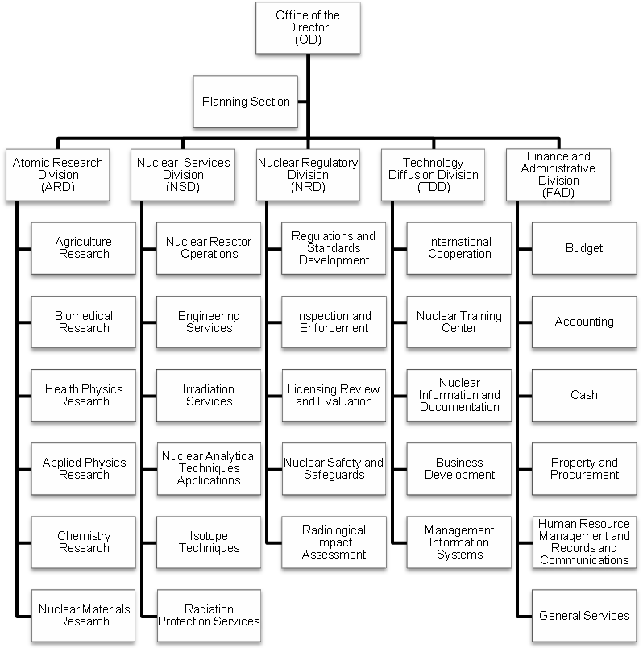
Figure 1. PNRI organizational structure

Staffing Summary
A total of 263 permanent positions make up the PNRI organization. Figure 2 shows how these positions are distributed in the different Divisions.
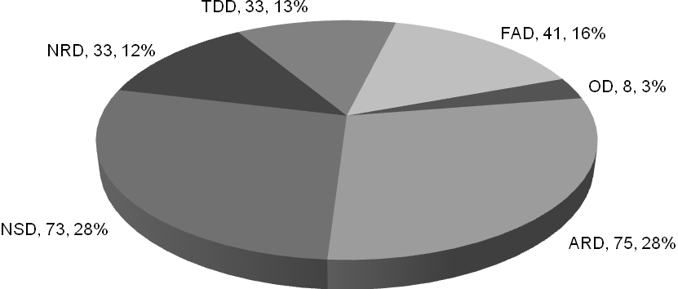
Figure 2. Distribution of PNRI positions

The PNRI SPMS Concept
The PNRI SPMS is focused on linking individual performance vis-à-vis the PNRI's organizational vision and mission. It is designed as a performance management system composed of strategies, methods and tools for ensuring fulfillment of the functions of PNRI and its personnel as well as for assessing the accomplishments.
This mechanism ensures that each employee contributes to the achievement of the objectives that the PNRI has set forth in its annual Work Plan.

General Objectives
The PNRI SPMS is prepared and administered to meet the following objectives:
  - Concretize the linkage of organizational performance with the Philippine Development Plan, the PNRI Nuclear S&T Plan, and the Organizational Performance Indicator Framework;
  - Ensure organizational effectiveness and improvement of individual employee efficiency by cascading institutional accountabilities to the various levels of the organization anchored on the establishment of rational and factual basis for performance targets and measures; and
  - Link performance management with other HR systems and ensure adherence to the principle of performance-based tenure and incentive system.

Basic Elements
The PNRI SPMS contains the following basic elements:
  - ALIGNMENT OF AGENCY MANDATE AND ORGANIZATIONAL PRIORITIES. Performance goals and measurement are aligned to the PNRI mandate/vision/mission, and the Organizational Performance Indicator Framework. Standards are pre-determined to ensure efficient use and management of inputs and work processes. These standards which are integrated into the success indicators as organizational objectives are cascaded down to operational level.
  - OUTPUTS/OUTCOMES-BASED. The system puts premium on major final outputs that contributes to the realization of organizational mandate, mission/vision, strategic priorities, outputs and outcomes.
  - TEAM-APPROACH TO PERFORMANCE MANAGEMENT. Accountabilities and individual roles in the achievement of organizational goals are clearly defined to give way to collective goal setting and performance rating. Individual's work plan or commitment and rating form is linked to the division/section work plan or commitment and rating form to establish clear linkage between organizational performance and personnel performance.
  - USER-FRIENDLY. The forms used for both the organizational and individual performance are similar and easy to accomplish. The organizational and individual major final outputs and success indicators are aligned to facilitate cascading of organizational goals to the individual staff members and the harmonization of organizational and individual performance ratings.
  - INFORMATION SYSTEM THAT SUPPORTS MONITORING AND EVALUATION. Monitoring and Evaluation (M&E) mechanisms and Information System are vital components of the SPMS in order to facilitate linkage between organizational and employee performance. The M&E and Information System ensure the generation of timely, accurate, and reliable information for both performance monitoring/tracking, accomplishment reporting, program improvement and policy decision-making.
  - COMMUNICATION PLAN. A program to orient PNRI officials and employees on the new policies on SPMS is to be implemented. This is to promote awareness and interest on the system, generate employees’ appreciation for the PNRI SPMS as a management tool for performance planning, control and improvement, and guarantee employees' internalization of their role as partners of management and co-employees in meeting organizational performance goals.

Key Players and Responsibilities

SPMS CHAMPION | PNRI DIRECTOR

Primarily responsible and accountable for the establishment and implementation of the PNRI SPMS

Sets agency performance goals/objectives and performance measures

Determines agency target setting period

Approves office performance commitment and rating

Assesses performance of Divisions

PERFORMANCE MANAGEMENT TEAM | PMT
PNRI set up a PMT under PNRI Special Order … dated … (Annex A) with the following composition:
Chair |
Co-Chair |
Members | Chief · Division
| Chief · Division
| Chief · Division
| Chief · Division
| Chief · Division
| Head · Planning Section
Head · Human Resource Management and Records and Communications (HRMRC) Section
President · PNRI Employees Union
The PMT is charged with the following functions and responsibilities:

Set consultation meeting of all Division Chiefs/Section Heads for the purpose of discussing the targets set in the office performance commitment and rating form

Ensure that Office performance targets and measures, as well as the budget are aligned with those of the agency and that work distribution of Divisions/Sections is rationalized

Recommend approval of the office performance commitment and rating to the Director

Act as appeals body and final arbiter for performance management issues of the agency

Identify potential top performers and provide inputs to the Program on Awards and Incentives for Service Excellence (PRAISE) Committee for grant of awards and incentives

Adopt internal rules, procedures and strategies in carrying out the above responsibilities including schedule of meetings and deliberations, and delegation of authority to representatives in case of absence of its members
The Planning Section serves as the PMT Secretariat.

PLANNING SECTION
In addition to serving as the PMT Secretariat, the Planning Section is tasked with the following duties:

Monitor submission of Division Performance Commitment and Review Form and schedule the review/evaluation of Division Commitments by the PMT before the start of the performance period

Consolidate, review, validate and evaluate the initial performance assessment of the Division Chiefs based on reported Division accomplishments against the success indicators, and the allotted budget against the actual expenses. The result of the assessment shall be the basis of PMT's recommendation to the PNRI Director who shall determine the final Division rating.

Conduct an agency performance planning and review conference annually including budget utilization for the purpose of discussing the Division assessment for the preceding performance period and plans for the succeeding rating period with concerned Division Chiefs.

Provide each Division with the final Division assessment to serve as basis of Divisions in the assessment of individual staff members

HUMAN RESOURCE MANAGEMENT AND RECORDS AND COMMUNICATIONS SECTION

Monitor submission of Individual Performance Commitment and Review Form after review by Division Chiefs/Section Heads

Review the Summary List of Individual Performance Rating to ensure that the average performance rating of employees is equivalent to or not higher than the Division Performance Rating as recommended by the PMT and approved by the PNRI Director

Provide analytical data on retention, skill/competency gaps, and talent development plans that align with strategic plans

Coordinate developmental interventions that will form part of the Human Resource Development Plan

DIVISION CHIEF

Assume joint responsibility with the PNRI Director in ensuring attainment of performance objectives and targets

Rationalize distribution of Division targets/tasks

Monitor closely the status of the performance of their subordinates and provide support and assistance through the conduct of coaching for the attainment of targets set by the Division

Recommend/implement developmental intervention

Section Head

Assume joint responsibility with the Division Chief in ensuring attainment of performance objectives and targets of the Division

Rationalize distribution of Section targets/tasks

Assess individual employee's performance

Monitor closely the status of the performance of their subordinates and provide support and assistance through the conduct of coaching for the attainment of targets set by the Section and individual employee

Recommend/implement developmental intervention

INDIVIDUAL EMPLOYEES

Act as partners of management and their co-employees in meeting organizational performance goals

The PNRI SPMS Process

The PNRI SPMS Cycle
The PNRI SPMS follows the four-stage performance management system cycle that underscores the importance of performance management as described here in Figure 3. A detailed process flowchart of the PNRI SPMS is presented in Annex B.
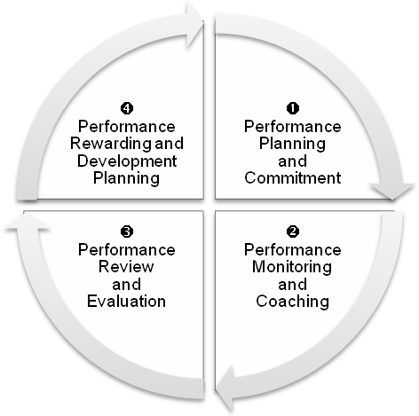
Figure 3. PNRI four-stage performance management system cycle
The PNRI SPMS Calendar (Annex C) chronicles the schedule of activities of the PNRI SPMS cycle. Indicated in this calendar is a plan—the PNRI SPMS Communication Plan (Annex D)—to ensure that all PNRI officials and employees are oriented on the policies of the PNRI SPMS.

Stage ❶
Performance Planning and Commitment
Performance planning and commitment is done prior to the start of the performance period when the PNRI Director meets with the Division Chiefs/Section Heads, and the latter with their respective staff, and agrees on the outputs that should be accomplished based on the objectives of the organization. The PNRI performance planning and commitment is illustrated in Annex E.
Success indicators are determined at this stage. These are performance level yardsticks consisting of performance measures and performance targets. This serves as the basis for the Division, Section and individual employee's preparation of their performance contract and rating form. The PNRI success indicators are shown in Annex F.
Only performance measures that are relevant to PNRI’s major final outputs and core functions, those that contribute to or support the outcomes that the PNRI aims to achieve, are included in the Division/Section performance contract, i.e. measures that are relevant to the PNRI major final outputs and core functions. The performance measures are to be continuously refined and reviewed.
Performance measures include any one, combination of, or all of the following general categories, whichever is applicable:
Quality The extent to which actual performance compares with targeted performance | The degree to which objectives are achieved and the extent to which targeted problems are solved | In management, effectiveness relates to getting the right things done.
Quantity The extent to which time or resources is used for the intended task or purpose | Measures whether targets are accomplished with a minimum amount or quantity of waste, expense, or unnecessary effort.
Timeliness Measures whether the deliverable was done on time based on the requirements of the law and/or clients/ stakeholders | Time-related performance indicators evaluate such things as project completion deadlines, time management skills and other time-sensitive expectations.
The PNRI Director causes the determination of the “agency target setting period.” This is the period within which the targets of the Divisions, Sections and employees are set and discussed by the raters and the ratees, reviewed and concurred by the Division Chiefs/Section Heads and submitted to the PMT. The PNRI Director fulfills this responsibility before the start of the performance period.
The PNRI will determine its success indicators using the following as basis:
  - Major Final Output (MFO). This refers to the goods or services that the PNRI is mandated to deliver to external clients through the implementation of programs, activities and projects as published by the Department of Budget and Management in the Organizational Performance Indicator Framework (OPIF) Book of Outputs.
  - Core Functions. This refers to the different functions performed by PNRI which are inherent in its mandate.
  - General Administration and Support Services. This refers to activities dealing with the provision of overall administrative management support to the entire operation of PNRI. It includes activities such as general management and supervision, human resource development, and financial and administrative services.
In setting work targets, the PNRI uses the following forms:
  - Section Performance Commitment and Review Form (SPCR, Annex G)
  - Individual Performance Commitment and Review Form (IPCR, Annex H)
The targets take into account the following:
  - Historical data. The data consider past performance.
  - Benchmarking. Identifying and comparing the Divisions or Sections within PNRI with similar functions or processes. It also involves recognizing existing standards based on provisions or requirements of the law.
  - Client demand. PNRI sets targets based on the needs of its clients. The PNRI may consult stakeholders and review the feedback on its services.
  - Top Management instruction. The PNRI Director may set targets and give special assignments.
  - Future trends. Targets may be based from the results of the comparative analysis of the actual performance of the PNRI with its potential performance.
In setting work targets, PNRI observes the last week of December as the cut-off date for the first semester targets of the coming year and the last week of June for the second semester targets.
Each Division will indicate its budgetary requirements per expense account to help the PNRI Director in ensuring a strategy-driven budget allocation and in measuring cost efficiency. The Division identifies a specific group or individuals primarily accountable for producing a particular target output per program/project/activity taking into consideration the budgetary allotment for the target year. These targets, performance measures, budget and responsibility centers are summarized in the SPCR form.
Amendments to the SPCR form are allowed at any time to accommodate intervening tasks subject to the review of the PMT and approval of the PNRI Director.
A meeting is to be held specifically for the purpose of reviewing the SPCR where Section Heads, in the presence of the Division Chiefs, present their respective SPCRs to the PNRI Director. The approved SPCR serves as basis for individual performance targets and measures to be prepared in the IPCR Form.
Standards are agreed upon by the supervisors and the ratees unless the work output of a particular duty has been assigned pre-set standards by management.
Individual employees' performance standards are not to be lower than the PNRI's standards in its approved SPCR form.

Stage ❷
Performance Monitoring and Coaching
During the performance monitoring and coaching phase, the performance of the Division, Section and individual employee is regularly monitored at various levels: i.e., the PNRI Director, Planning Section, Division Chief, Section Head and individual, on a regular basis, but is not be limited to the following schedule:
  - The PNRI Director reviews the performance of the Divisions at least once every six months.
  - The Planning Section summarizes and analyzes the performance of every Division at the end of each performance/rating period.
  - The Division Chief and Section Head monitor at least once every quarter the performance of Sections and employees under them. He/She meets with them to discuss the performance and the progress of work.
  - Each individual likewise monitors and assesses his/her performance at least once a month.
Monitoring and evaluation mechanisms (one-on-one, group discussion, memorandum and review of pertinent documents) are in place to ensure that timely and appropriate steps can be taken to keep a program on track and to ensure that its objectives or goals are met in the most effective manner. Also a very vital tool of management at this stage is an information system that will support data management to produce timely, accurate and reliable information for program tracking and performance monitoring/reporting.
Division Chiefs and Section Heads play a critical role at this stage. The focus is on the critical function of supervisors as coaches and mentors in order to provide an enabling environment/ intervention to improve team performance; and manage and develop individual potentials.
The Section Heads maintain a journal using the Performance Monitoring and Coaching Journal (Annex I) to record the conduct of monitoring and coaching which contain the date and form of monitoring/coaching, brief statement of the purpose of monitoring/coaching, name of persons monitored/coached as well as critical incidents, if any.

Stage ❸
Performance Review and Evaluation
This phase assesses the Section’s and the individual employee's performance level based on performance targets and measures as approved in the office and individual performance commitment contracts (SPCR and IPCR).
The results of assessment of the Section and individual performance are to be impartial owing to scientific and verifiable basis for target setting and evaluation.

Division Performance Assessment
At the end of the semester, the respective Division Chiefs assesses the performance of their Sections and submit their accomplishments using the SPCR form to the Planning Section for evaluation/validation.
The Planning Section consolidates, reviews, validates and evaluates the initial performance assessment of the Division Chiefs based on reported accomplishments against the success indicators, and the allotted budget against the actual expenses. The Planning Section returns to the Divisions the validated accomplishments within 10 working days from receipt of their respective SPCR forms. The concerned Division and Section are given five working days to comment on the validated accomplishments, otherwise, the Planning Section considers it as final for submission to the PMT. The latter recommends to the PNRI Director the final rating of the Division.
An agency performance review conference is to be conducted annually by the Planning Section for the purpose of discussing the office assessment with Division Chiefs. To ensure complete and comprehensive performance review, all divisions are to submit a quarterly accomplishment report to the Planning Section based on the PNRI SPMS Calendar.
Any issue/appeal/protest on the Division assessment is to be articulated by the concerned Division Chief and decided by the PNRI Director during this conference. Hence, the final rating is no longer appealable or contestable after the conference.
The Planning Section provides each Division with the final Division assessment to serve as basis of the Division in the assessment of individual staff members.

Performance Assessment for Individual Employees
The Section Head assesses the individual employee's performance based on the commitments made at the beginning of the rating period. The performance rating is based solely on records of accomplishment.
The PNRI SPMS puts premium on major final outputs towards the realization of the organizational mission/vision. Hence, rating for planned and/or intervening tasks will always be supported by reports, documents or any outputs as proofs of actual performance. In the absence of said bases or proofs, a particular task will not be rated and will be disregarded.
The Section Head indicates qualitative comments, observations and recommendations in the individual employee's performance commitment and review form to include competency assessment and critical incidents which will be used for human resource development purposes such as promotion and other interventions.
Employee's assessment is to be discussed by the Section Head with the concerned ratee prior to the submission of the individual employee's performance commitment and review form to the Division Chief.
The Division Chief determines the final assessment of performance level of the individual employees in his/her Division based on proof of performance. The final assessment corresponds to the adjectival description of Outstanding, Very Satisfactory, Satisfactory, Unsatisfactory or Poor.
The averages of all individual performance assessments are not to go higher than the collective performance assessment of the Division.
The Division Chief ensures that the employee is notified of his/her final performance assessment and that the Summary List of Individual Performance Ratings (Annex L) with the IPCRs attached thereto is submitted to the HRMRC Section within the prescribed period.

Stage ❹
Performance Rewarding and Development Planning
Part of the individual employee's evaluation is the competency assessment vis-à-vis the competency requirements of the job. The result of the assessment is to be discussed by the Section Head with the individual employee at the end of each rating period. The discussion is to focus on the strengths, competency-related performance gaps and the opportunities to address these gaps, career paths and alternatives.
The result of the competency assessment is to be treated independently of the performance rating of the employee.
Appropriate developmental interventions will be made available by the PNRI Director and Section Heads in coordination with the HRMRC Section.
A professional development plan to improve or correct performance of employees with Unsatisfactory and Poor performance ratings is to be outlined, including timeliness, and monitored to measure progress.
The results of the performance evaluation/assessment serve as inputs to the:
  - Division Chief in identifying and providing the kinds of interventions needed, based on the developmental needs identified;
  - HRMRC Section in consolidating and coordinating developmental interventions that will form part of the HRD Plan;
  - PMT in identifying potential PRAISE Awards nominees for various awards categories; and,
  - PRAISE Committee in determining top performers of the PNRI who qualify for awards and incentives.

Rating Period
Performance evaluation is to be done semi-annually.

Rating Scales
The following rating scales are to be used in the PNRI SPMS. In general, they are a five-point rating scale (1 to 5): 5 being the highest and 1 the lowest.

for General Use
Quality of Written Work
Numerical | Adjectival | Description
5 | Outstanding | - One or no revisions at all  - Every aspect of work assignment well covered  - Clearly presented  - Well organized
4 | Very Satisfactory | - Two revisions at most
3 | Satisfactory | - Four revisions at most
2 | Unsatisfactory | - Written work not acceptable
1 | Poor | - No work done
Quality of Non-Written Work
Numerical | Adjectival | Description
5 | Outstanding | - Excellent results  - No errors/deficiencies in the execution of work assignment  - All aspects of work assignment thoroughly covered
4 | Very Satisfactory | - Results still very good  - 1 or 2 minor errors/deficiencies in the execution of work assignment
3 | Satisfactory | - Results are acceptable  - More than 2 minor errors/deficiencies in the execution of work assignment
2 | Unsatisfactory | - 1 major error/deficiency that can be overcome with the help from supervisor
1 | Poor | - Results are unacceptable  - Haphazard or careless execution of work assignment
Quantity of Work
Numerical | Adjectival | Description
5 | Outstanding | - Performance exceeded expectations by at least 20% of the planned targets
4 | Very Satisfactory | - Performance exceeded expectations by at least 10% of the planned targets
3 | Satisfactory | - Performance met 100% of the planned targets
2 | Unsatisfactory | - Performance only met 80% of the planned targets and failed to deliver one or more critical aspects of the target
1 | Poor | - Performance delivered less than 80% of the targets
Timeliness
Numerical | Adjectival | Description
5 | Outstanding | - Task completed 20% before the deadline or scheduled time of completion
4 | Very Satisfactory | - Task completed 10% before the deadline or scheduled time of completion
3 | Satisfactory | - Task completed within the deadline or scheduled time of completion
2 | Unsatisfactory | - Task completed 1 – 5 working days after the deadline or scheduled time of completion
1 | Poor | - Task not completed at all or completed 6 working days after the deadline or scheduled date of completion

for R&d Work
Quality of R&D Work
Numerical | Adjectival | Description
5 | Outstanding | - Expected output exceeded by at least 30%
4 | Very Satisfactory | - Expected output exceeded by at least 15%
3 | Satisfactory | - Achieved expected output
2 | Unsatisfactory | - Failed to accomplish up to 70% of the expected output
1 | Poor | - Failed to accomplish more than 70% of expected output
Quantity of R&D Work Completed and Disseminated
Numerical | Adjectival | Description
5 | Outstanding | - Planned quantity exceeded by at least 30%
4 | Very Satisfactory | - Planned quantity exceeded by at least 15%
3 | Satisfactory | - Planned quantity just met
2 | Unsatisfactory | - Failed to accomplish up to 70% of planned work
1 | Poor | - Failed to accomplish more than 70% of planned work
Timeliness of R&D WorkError: Reference source not found
Numerical | Adjectival | Description
5 | Outstanding | - Task completed within 3 months before or on scheduled time of completion
4 | Very Satisfactory | - Task completed within 1 month before or on scheduled time of completion
3 | Satisfactory | - Completed at least 85% of work on scheduled time of completion
2 | Unsatisfactory | - Completed less than 85% of work on scheduled time of completion
1 | Poor | - Completed less than 70 % of work on scheduled time of completion

Appeals
An individual employee who feel aggrieved or dissatisfied with his/her final performance rating can file an appeal with the PMT within ten (10) days from the date of receipt of notice of his/her final performance evaluation rating from the Division Chief. A Division or Section or individual employee, however, is not allowed to protest the performance ratings of other Divisions/Sections or co-employees. Ratings obtained by other Divisions/Sections or employees can only be used as basis or reference for comparison in appealing one's office or individual performance rating.
The PMT is to decide on the appeals within one month from receipt.
Officials or employees who are separated from the service on the basis of Unsatisfactory or Poor performance rating can appeal their separation to the CSC Regional Office within 15 days from receipt of the order or notice of separation.

Sanctions
Unless justified and accepted by the PMT, non-submission of the DPCR form to the PMT and the IPCR forms to the HRMRC Section within the specified dates is a ground for:
  - Employees' disqualification for performance-based personnel actions which would require the rating for the given period such as promotion, training or scholarship grants and performance enhancement bonus, if the failure of the submission of the report form is the fault of the employees.
  - An administrative sanction for violation of reasonable office rules and regulations and simple neglect of duty for the supervisors or employees responsible for the delay or non-submission of the Division and Individual Performance Commitment and Review Report.
  - Failure on the part of the Division Chief to comply with the required notices to their subordinates for their unsatisfactory or poor performance during a rating period shall be a ground for an administrative offense for neglect of duty.
  - Non-submission of PNRI SPMS to the Civil Service Commission for review/approval is a ground for disapproval of promotional appointments issued by the PNRI Director.

Uses of Performance Ratings
Performance ratings reflect how employees stand against their organization’s performance standards and how they compare against the rest of the population. For this reason, it is critical that the true performance of employees are gauged in order to reap a number of benefits:
  - Security of tenure of those holding permanent appointments is not absolute but is based on performance.
Employees who obtained Unsatisfactory rating for one rating period or exhibited poor performance will be provided appropriate developmental intervention by the PNRI Director and the Division Chief/Section Head, in coordination with the HRMRC Section, to address competency-related performance gaps.
If after advice and provision of developmental intervention, the employee still obtains Unsatisfactory ratings in the immediate succeeding rating period or Poor rating for the immediate succeeding rating period, he/she may be dropped from the rolls. A written notice issued by the PNRI Director is required within the period stated in CSC Memorandum Circular No. 40, s. 1998, as amended.
  - The PMT validates the Outstanding performance ratings and may recommend concerned employees for performance-based awards. Grant of performance-based incentives is to be based on the final ratings of employees as approved by the PNRI Director.
  - Performance ratings are to be used as basis for promotion, training and scholarship grants and other personnel actions.
Employees with Outstanding and Very Satisfactory performance ratings are to be considered for the above mentioned personnel actions and other related matters.
  - Officials and employees who will be on official travel, approved leave of absence or training or scholarship programs and who have already met the required minimum rating period of ninety (90) days are to submit the performance commitment and rating report before they leave the office.
For purposes of performance-based benefits, employees who are on official travel, scholarship or training within a rating period are to use their performance ratings obtained in the immediately preceding rating period.
  - Employees who are on detail or secondment to another office are to be rated in their present or actual office, copy furnished their mother office. The ratings of those who were detailed or seconded to another office during the rating period are to be consolidated in the office, either the mother (plantilla) office or present office, where the employees spend majority of their time during the rating period.

Transparency on Performance Ratings
General information on the final rating of the employees is to be made known to both management and concerned rank and file employee subject to the procedures set by the PMT.

Effectivity
The PNRI SPMS takes effect in the next rating period after its approval by the CSC. It is, however, to be pilot-tested on July 1, 2014.

Special Order: PNRI-SPMS Performance Management Team

SPMS Process Flowchart
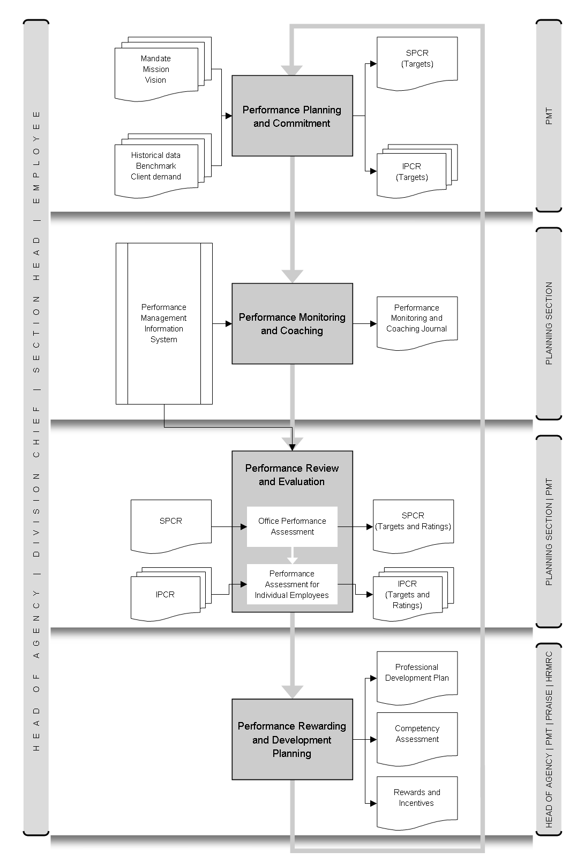

SPMS Calendar
Stage ❶ Performance Planning and Commitment
Activity | Submission to | Jan | Feb | Mar | Apr | May | Jun | Jul | Aug | Sep | Oct | Nov | Dec
DPCR for review | PMT |  |  | ☑
PMT review report | Director |  |  |  | ☑
Approval of DPCR by Director |  |  |  |  |  | ☑
IPCR | Section Head |  |  |  |  |  | ☑
 IPCR | Division Chief |  |  |  |  |  | ☑
 IPCR | HRMRC |  |  |  |  |  | ☑
Stage ❷ Performance Monitoring and Coaching
Monitoring by:
Director | ☑ Once every six months
Planning Section | ☑ Per semester (6 months)
Division Chief | ☑ Quarterly
Section Head | ☑ Quarterly
Individual Employee | ☑ Once a month
Submission of forms | ☑ After the end of quarter to Planning Section
Stage ❸ Performance Review and Feedback
Activity | Concerned Entity | Jan | Feb | Mar | Apr | May | Jun | Jul | Aug | Sep | Oct | Nov | Dec
SPCR for validation against targets | Planning Section |  |  |  |  |  |  |  |  |  |  |  | ☑
Return of validated SPCR to Division Chief | Planning Section |  |  |  |  |  |  |  |  |  |  |  | ☑
Submission of Office Performance Assessment and facilitate performance review by the Director | Planning Section |  |  |  |  |  |  |  |  |  |  |  | ☑
Annual Performance Review | Director |  |  |  |  |  |  |  |  |  |  |  | ☑
IPCR | Section Head |  |  |  |  |  |  | ☑ | ☑ | ☑ | ☑ | ☑ | ☑
Submission of IPCR to HRMRC | Division Chief |  |  |  |  |  |  |  |  |  |  |  | ☑
Stage ❹ Performance Rewarding and Development Planning
Activity | Submission to | Jan | Feb | Mar | Apr | May | Jun | Jul | Aug | Sep | Oct | Nov | Dec
PMT to submit Top Performers List | Director |  |  |  |  |  |  |  |  |  |  |  | ☑

SPMS Communication Plan
The PNRI SPMS Communication Plan outlines the program of activities to orient PNRI officials and employees on the SPMS. This is to promote awareness and interest on the system, generate employees’ appreciation for the agency SPMS as a management tool for performance planning, control and improvement, and guarantee employees’ internalization of their role as partners of management and co-employees in meeting organizational performance goals.
MAIN ACTIVITIES
Conduct of PNRI SPMS Awareness Orientation Seminar
The approved PNRI SPMS will be communicated to all employees of the Institute through an Awareness Orientation Seminar to be initiated by the Performance Management Team. There will be two separate orientation seminars: one is for the Division Chiefs and Section Heads of the Institute and the other is for the rest of the rank and file. These two seminars will be done within the month after the approval of the PNRI SPMS by the CSC.
Preparation of Section Performance Commitment Forms (SPCR)
Within two weeks after the PNRI SPMS Awareness Orientation Seminar, Division Chiefs and Section Heads will meet together to formulate the SPCRs as prescribed in the approved SPMS.
Review of the SPCR by the PMT and Endorsement for the Approval of the Director
A review of the SPCR will be conducted by the PMT in May. After which, the SPCR will be endorsed to the Director for review and/or approval.
Dissemination of Information on the SPCR
Within one week after the Director approves the SPCR, the approved SPCR will be disseminated and discussed by the respective Division Chiefs with their Section Heads. Section Heads will meet with their staff to discuss/adjust their respective SPCR.
Preparation of the Individual Performance Commitment Form (IPCR)
Section Heads will meet with their staff to plan and identify each employee's role in the achievement of the Section's target/commitments based on their respective SPCRs. The Individual Performance Commitment Form will be prepared and submitted by every PNRI employee to the Section Head for endorsement to the Division Chief who then endorses it to the PMT.

Performance Planning and Commitments
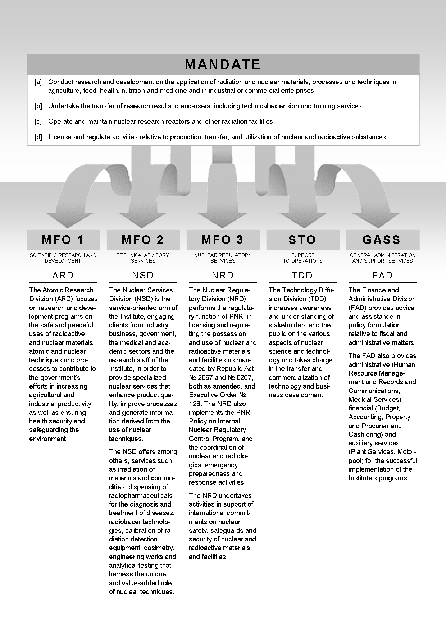
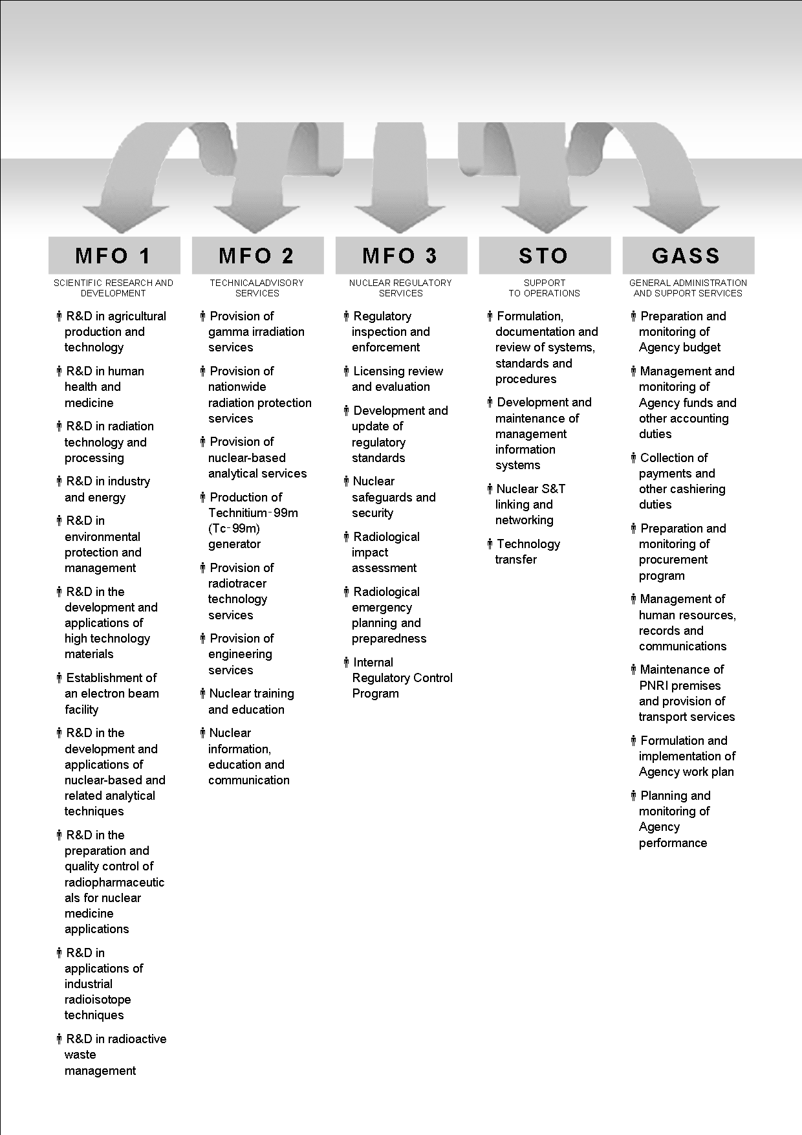

Success Indicators
MFO 1: Scientific Research and Development
PERFORMANCE  MEASURE | PERFORMANCE  TARGET | SUCCESS INDICATOR  (Target + Measure)
Quantity | Number of projects completed and disseminated | 100% completion and dissemination of targeted number of projects
Quality | Percentage of projects completed in the last five years that are published in recognized media or adopted by the industry | 100% publication in recognized media or adoption by the industry of projects completed in the last five years
Timeliness | Percentage of projects completed within the timeframe in accordance with original project approval | 100% completion of projects based on the approved duration
MFO 2: Technical Advisory Services
PERFORMANCE  MEASURE | PERFORMANCE  TARGET | SUCCESS INDICATOR  (Target + Measure)
Quantity | Number of technical advisory services rendered | 100% delivery of targeted technical advisory services
Quality | Percentage of clients who rate the technical advisory services as satisfactory or better | 85% of clients rated the technical advisory services as satisfactory or better
Timeliness | Percentage of technical advisory services rendered within the prescribed period | 100% of requested technical advisory services rendered within the prescribed period
MFO 3: Nuclear Regulatory Services
PERFORMANCE  MEASURE | PERFORMANCE  TARGET | SUCCESS INDICATOR  (Target + Measure)
Quantity | Number of site inspections | 85% completion of targeted number of sites inspected
Quality | Percentage of detected violations that are acted on within five minutes | 85% of detected violations acted on within five minutes
Timeliness | Percentage of sites that have been inspected more than twice in the last three years | 85% completion of inspection of sites inspected within the last three years
Quantity | Number of licenses and permits issued | 85% completion of evaluation of received applications for radioactive material licenses
Quality | Number of violation of regulations detected over the last five years as a percentage of the average number of licenses and permits on issue over the last five years
Timeliness | Percentage of permit or license applications processed within fourteen (14) days of receipt
Support to Operations
PERFORMANCE  MEASURE | PERFORMANCE  TARGET | SUCCESS INDICATOR  (Target + Measure)
Quantity | ISO Certifications maintained | Number of certifications maintained
Quality | Percentage completion of information systems/modules planned for development and maintenance required for existing systems | 100% of information systems/modules developed and maintained

General Administration and Support Services
Human Resources Management and Records and Communications
GASS | Performance  Measure | Performance  Target | SUCCESS INDICATOR  (Target + Measure)
Publication of vacant positions | Timeliness, quality | Vacancies submitted to CSC | Submitted to CSC within a day of directive for publication, no error
Issuance of Appointments | Timeliness, quality | Appointments submitted to CSC | Submitted to CSC 30 days upon issuance with no errors
Updating of leave credits | Timeliness | Leave credits updated | Leave credits of employees updated by 5th day of following quarter
Budget
GASS | Performance  Measure | Performance  Target | SUCCESS INDICATOR  (Target + Measure)
Annual Budget Preparation | Timeliness | Budget Proposals prepared and submitted | Submitted to DOST DBM, Senate & House of Representatives on the prescribed deadline.
Budget Implementation | Timeliness | Claims and requests acted upon | Obligation Request (ObR) issued within two (2) working days after receipt of complete documents.
Budget Accountability | Timeliness | Reports submitted | Reports submitted on the prescribed dates.
Property and Procurement
GASS | Performance  Measure | Performance  Target | SUCCESS INDICATOR  (Target + Measure)
Procurement (Alternative Methods) | Timeliness | Purchase Order (PO) / Job Order (JO) Issued to Supplier | PO/JO issued to supplier 30 working days for locally available supplies and 45 working days for imported supplies after receipt of approved PR
Procurement (Public Bidding) | Timeliness | Contract / PO Prepared | Contract / PO prepared three (3) working days after Notice of Award is signed
Issuance of Delivered Items | Timeliness | Items issued to end user | Delivered Items Issued to end-user after three (3) working days
Physical Inventory | Timeliness | Physical inventory submitted | Report of Annual Physical Inventory submitted to Agency Head within the prescribed deadline
Buildings and Equipment Insurance | Timeliness | Buildings and Equipment Insured | Buildings and Equipment insured on the renewal dates
Cash
GASS | Performance  Measure | Performance  Target | SUCCESS INDICATOR  (Target + Measure)
Collection and Deposit | Timeliness | - Issuance of OR  - Deposit of collection(s)  - Report of Collection and Deposit (RCD) submitted  - Accountability Report of Official Receipts (AROR) submitted  - Report of Collection and Deposit in Implementation of Remittance System of the National Treasury (RCDURSBT) submitted  - Cash Book for Issued Official Receipts (CBIOR) updated | - Issuance of OR to client within 20 minutes.  - Collection(s) deposited on the following working day.  - Report of Collection and Deposit (RCD) submitted to Accounting Section on the 5th day of the following month.  - AROR submitted to COA on the fifth (5th) day of the following month  - RCDURSBT submitted to BTR on the fifth (5th) day of the following month  - CBIOR updated daily
Check Preparation | Timeliness | Check with ACIC prepared | Check with ACIC prepared within three (3) working days after receipt of Disbursement Voucher
Check Releasing | Timeliness | - Notification to payees for check ready for release  - Report of Check Issued by Deputized Disbursing Officer (RCIDDO) submitted  - Report of Cancelled and Spoiled Checks (RCSC) submitted  - Accountability Report of Checks (ARC) submitted | - Payee formally notified within three (3) working days after submission of checks and corresponding Advice of Checks Issued and Cancelled to the authorized depository bank.  - RCIDDO submitted to Accounting Section on the fifth (5th) day of the following month.  - RCSC submitted to Accounting Section on the fifth (5th) day of the following month.  - ARC submitted to Accounting Section on the fifth (5th) day of the following month.
Payroll Preparation | Timeliness | - Payroll/s prepared  - Report of Cash Disbursement Report (RCD) submitted  - Cash Disbursement Records (CDR) updated | - Regular payroll prepared on the 5th working day of the following month.  - Payroll for allowances prepared within three (3) days upon receipt of data from HRMRCS  - RCD submitted to Accounting Section on the fifth (5th) day of the following month  - CDR updated on the 5th day of the month
Compliance to BIR, GSIS, Philhealth and HDMF | Timeliness | Check remitted | Remittance of contributions paid on the 10th day of the following month
General Services
GASS | Performance  Measure | Performance  Target | SUCCESS INDICATOR  (Target + Measure)
Repair, Maintenance and Monitoring of Infrastructure Projects | Timeliness | Percentage of services provided within the prescribed time | 100% Carpentry Services provided within the day for emergency needs; as per job order schedule for other needs
Repair, Maintenance and Monitoring of Infrastructure Projects | Quality | Percentage of clients who rate the services as satisfactory | 90% of clients rates the services as satisfactory
Repair, Maintenance and Monitoring of Infrastructure Projects | Timeliness | Percentage of services provided within the prescribed time | 100% Plumbing Services provided within the day for emergency needs; as per job order schedule for other needs
Repair, Maintenance and Monitoring of Infrastructure Projects | Quality | Percentage of clients who rate the services as satisfactory | 90% of clients rate the services as satisfactory
Repair, Maintenance and Monitoring of Infrastructure Projects | Timeliness | Percentage of services provided within the prescribed time | 100% Minor Electrical Services provided within the day for emergency needs; as per job order schedule for other needs
Repair, Maintenance and Monitoring of Infrastructure Projects | Quality | Percentage of clients who rate the services as satisfactory | 90% of clients rate the services as satisfactory
Repair, Maintenance and Monitoring of Infrastructure Projects | Timeliness | Monitoring of infrastructure projects | Projects completed on time
Reproduction Services | Timeliness | Percentage of services provided within the prescribed time | Reproduction of print materials performed within the day for emergency needs; as per job order schedule for other needs
Reproduction Services | Quality | Percentage of clients who rate the services as satisfactory | 90% of clients rate the services as satisfactory
Provision of Transportation Services | Quality | Percentage of Clients who rate the service as satisfactory | 90% of clients rated the transportation service provided as satisfactory
Provision of Transportation Services | Timeliness | Registration and Insurance Renewal | Registration and insurance renewal done on renewal date
Office of the Director
GASS | Performance  Measure | Performance  Target | SUCCESS INDICATOR  (Target + Measure)
Agency Planning | Timeliness | Preparation of Agency Work Plan and targets | 100% if work plan and targets are completed and submitted on or before the prescribed period
Agency Performance Monitoring | Timeliness | Monitoring of Agency accomplishments | 100% if accomplishment report is completed and submitted on or before the prescribed period
Agency Performance Monitoring | Quality | Documents are accepted and processed | 100% if no revisions are required

Section Performance and Commitment Review Form
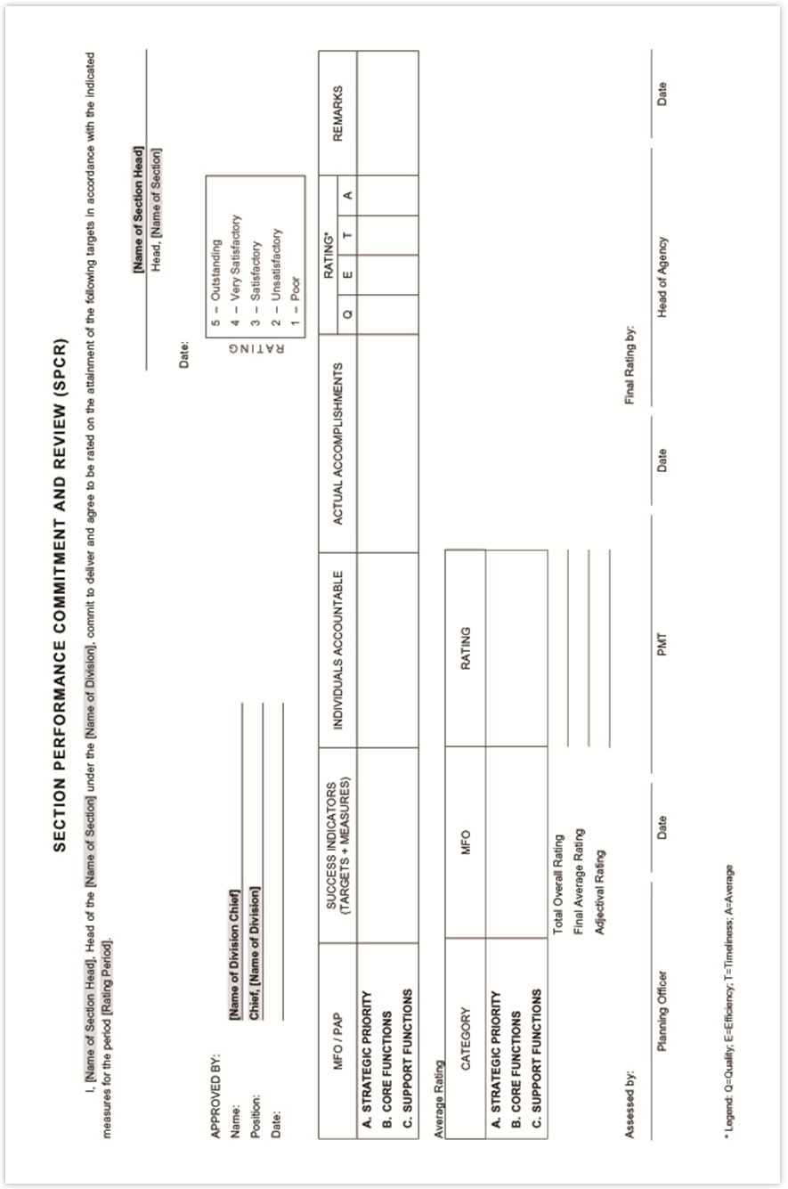

Individual Performance and Commitment Review Form
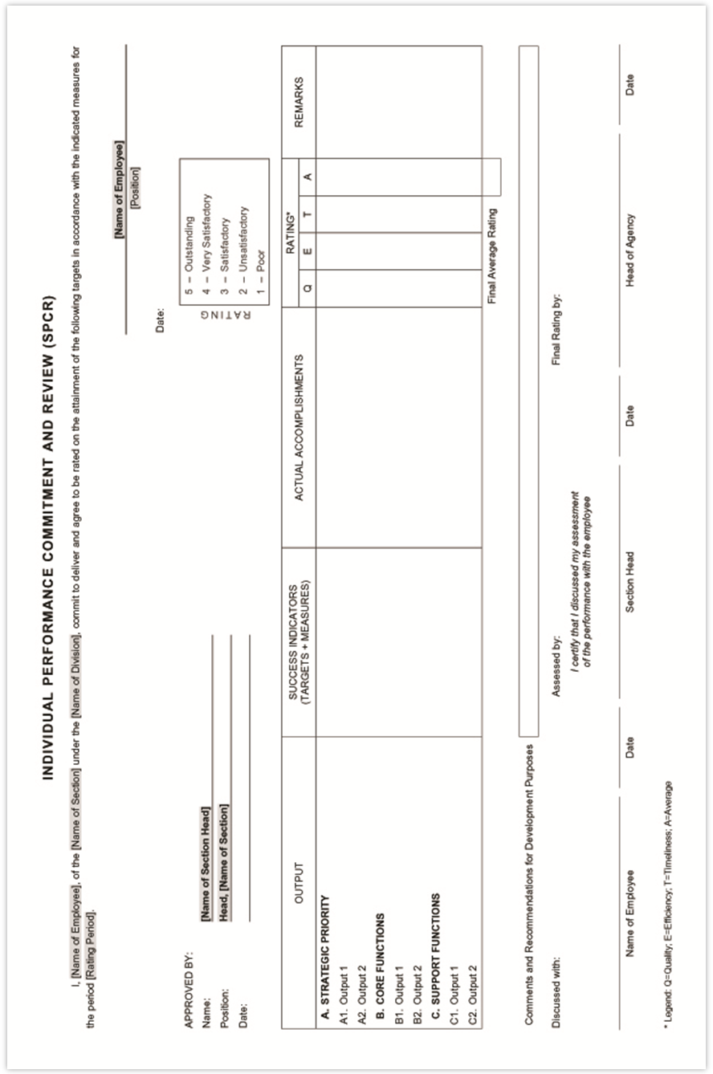

Performance Monitoring and Coaching Journal
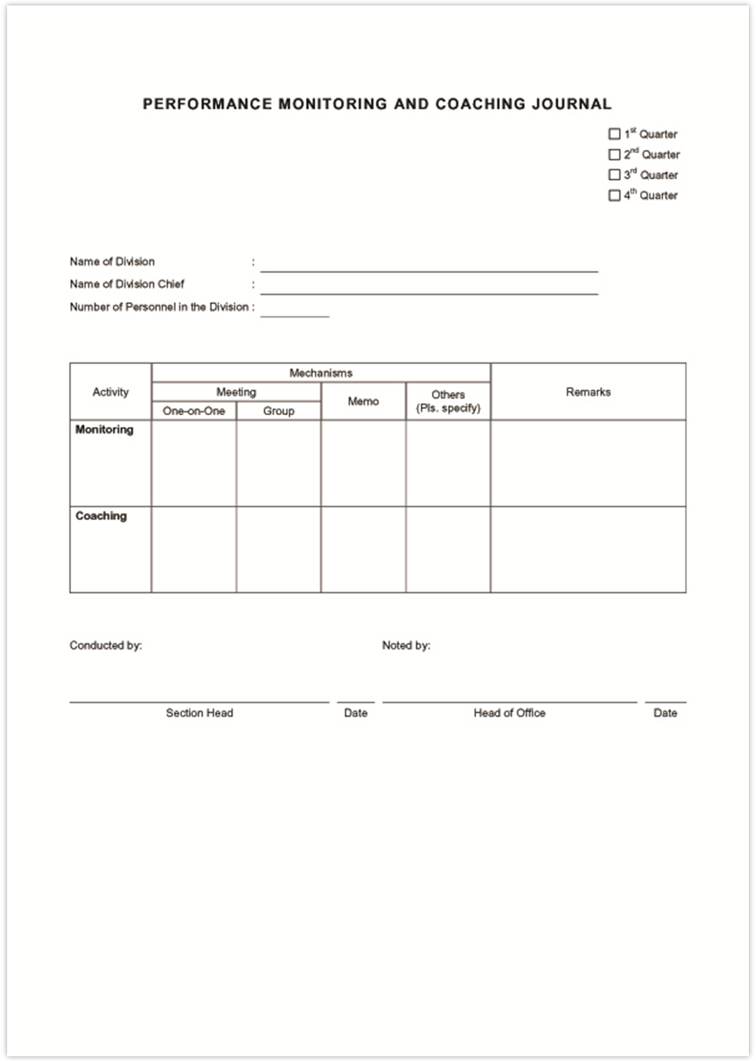

Division Performance Monitoring and Coaching Form
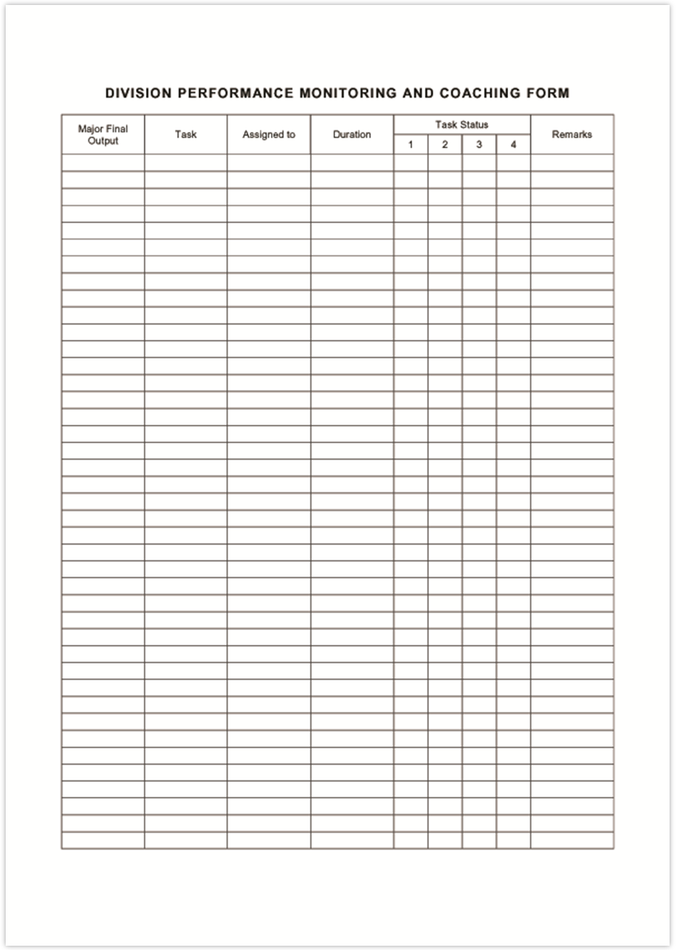

Individual Performance Monitoring and Coaching Form
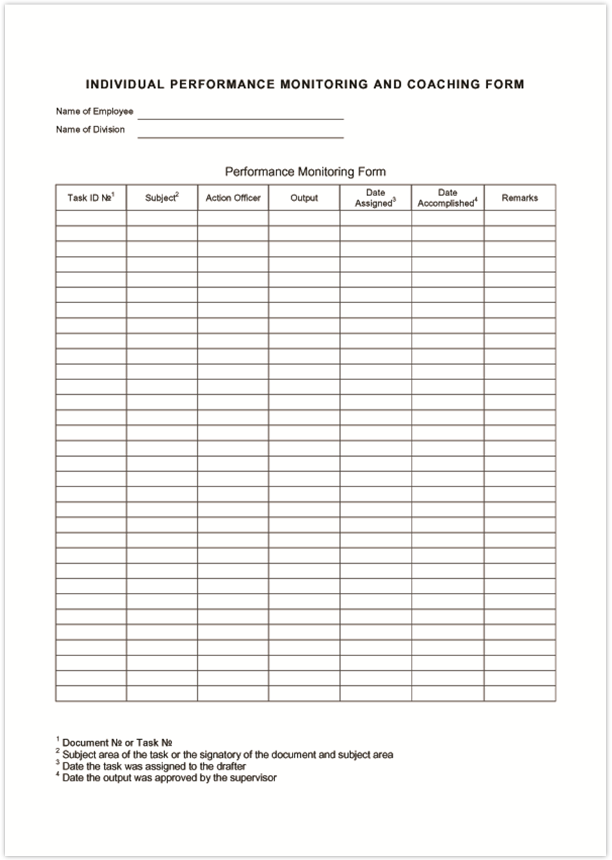

Sample Summary List of Individual Performance Ratings
PNRI Performance Assessment
Very Satisfactory
- Division One
Name of Employee | Numerical Rating | Adjectival Description
- Division Chief | 4 | Very Satisfactory
- Section Head 1 | 4 | Very Satisfactory
- Section Head 2 | 4 | Very Satisfactory
- Employee 1 | 4 | Very Satisfactory
- Employee 2 | 3 | Satisfactory
Average | 3.8 | Very Satisfactory
- Division Two
Name of Employee | Numerical Rating | Adjectival Description
- Division Chief | 3 | Satisfactory
- Section Head 1 | 3 | Satisfactory
- Section Head 2 | 3 | Satisfactory
- Employee 1 | 4 | Very Satisfactory
- Employee 2 | 3 | Satisfactory
Average | 3.2 | Satisfactory
- Division Three
Name of Employee | Numerical Rating | Adjectival Description
- Division Chief | 5 | Outstanding
- Section Head 1 | 5 | Outstanding
- Section Head 2 | 4 | Outstanding
- Employee 1 | 5 | Outstanding
- Employee 2 | 4 | Very Satisfactory
Average | 4.6 | Outstanding
- Summary
Name of Employee | Numerical Rating | Adjectival Description
- Division One | 3.8 | Very Satisfactory
- Division Two | 4.2 | Satisfactory
- Division Three | 4.6 | Outstanding
Average | 4.2 | Very Satisfactory

Basis of Rating Scale for Quality of R&D Work
- POINT SYSTEM FOR QUALITY OF COMPLETED R&D WORK
  - Weight According to Position Job Description
Position | Concept and design | Data Collection and processing | Analysis and Interpretation | Synthesis and Composition
- Chief Science Research Specialist | Major | Minor | Major | Major
- Supervising Science Research Specialist | Major | Minor | Major | Major
- Senior Science Research Specialist | Major | Minor | Major | Major
- Science Research Specialist II | Minor | Major | Major | Minor
- Science Research Specialist I | N/A | Major | Minor | Minor
- Science Research Analyst | N/A | Major | Minor | N/A
- Science Research Assistant | N/A | Major | N/A | N/A
  - Publications
Type of Publication | Concept and design |  | Data Collection and processing |  | Analysis and Interpretation |  | Synthesis and Composition
Type of Publication | Major | Minor | Major | Minor | Major | Minor | Major | Minor
    - Journals, book chapters, proceedings
- ISI | 15 | 7 | 15 | 7 | 15 | 7 | 15 | 7
- Non-ISI refereed | 10 | 4 | 10 | 4 | 10 | 4 | 10 | 4
- Non-refereed | 7 | 3 | 7 | 3 | 7 | 3 | 7 | 3
- Full Technical Reports | 5 | 2 | 5 | 2 | 5 | 2 | 5 | 2
- Others (Newsletter articles, feature articles, abstracts, etc.) | 3 | 1 | 3 | 1 | 3 | 1 | 3 | 1
  - Intellectual Property (IP)
IP Status | Concept and design |  | Data Collection and processing |  | Analysis and Interpretation |  | Synthesis and Composition
IP Status | Major | Minor | Major | Minor | Major | Minor | Major | Minor
    - Registered IP
- International | 15 | 7 | 15 | 7 | 15 | 7 | 15 | 7
- Local | 10 | 4 | 10 | 4 | 10 | 4 | 10 | 4
- Pending IP | 7 | 3 | 7 | 3 | 7 | 3 | 7 | 3
- Non-Patentable Inventions | 5 | 2 | 5 | 2 | 5 | 2 | 5 | 2
  - Technologies Adopted
Type of Technology | Concept and design |  | Data Collection and processing |  | Analysis and Interpretation |  | Synthesis and Composition
Type of Technology | Major | Minor | Major | Minor | Major | Minor | Major | Minor
- Commercialized/Regulatory Policies | 15 | 7 | 15 | 7 | 15 | 7 | 15 | 7
- Contract Service/MOA | 10 | 4 | 10 | 4 | 10 | 4 | 10 | 4
  - Paper and Poster on R&D Results Presented
Venue of Presentation | Major | Minor
- International Conferences, Symposium | 5 | 3
- Local (National Conferences, Congress, Symposium) | 3 | 1
- Institutional/Meetings/ Workshops | 1 | 0.5
  - Recommended Points to Meet a SATISFACTORY Rating
Position | Concept and design | Data Collection and processing | Analysis and Interpretation | Synthesis and Composition | Total
- Chief Science Research Specialist | 5 | 2 | 5 | 5 | 17
- Supervising Science Research Specialist | 5 | 2 | 5 | 5 | 17
- Senior Science Research Specialist | 5 | 4 | 10 | 7 | 26
- Science Research Specialist II | 2 | 10 | 10 | 2 | 24
- Science Research Specialist I | N/A | 10 | 7 | 2 | 19
- Science Research Analyst | N/A | 10 | 4 | N/A | 14
- Science Research Assistant | N/A | 10 | N/A | N/A | 10
  - Explanatory remarks
1. It is assumed that the normal R and D load for a research personnel, exept for the Spvng SRS and the Chief SRS, is two projects per staff
2. Based on postion description, a Senior SRS is expected to be conducting independent research, thus should already be a project leader or al least a study leader for one project
3. Aside from their supervisory and administrative functions, a Supervising SRS and a Chief SRS can still conduct independent research
4. Definitions:
a) Major - contribution to the identified aspect of work is significant
b) Minor - contribution to the identified aspect of work is minor
c) Recognized media include the following:
i. Publications - results of work expressed in print; as in scientific journals; books; proceedings of conferences, symposia, and technical meeting; manuals; publishedfinal reports of projects (with ISBN);
theses, dissertations; internal full technical reports submitted for PNRI library; book of abstracts; newsletters, Institutiom annual reports, newspaper articles, popular magazine articles
ia. ISI Publications - articles that are published in Journals included in the Web of Science and are in searchable databases
ib. Non- ISI but refereed journals, e.g, PNJ, KIMIKA, Science Diliman, The Nucleus, etc. This classification also includes MS and PhD dissertations, refereed proceedings; manuals and protocols.
ic. Non-refereed publications include published proceedings of meetings, conferences, and full reports of projects completed
id. Internal Technical Reports - Full reports of results of studies following formats of journals, submitted for TRRC evaluation and approved by the Director.
ie. Others: These include book of abstracts; newsletters, Institutiom annual reports, newspaper articles, popular magazine articles, PNRI website article, brochures
ii. IP -Patents for discoveries and inventions; registration for nonpatentable inventions such as ① Discovery | ② Scientific theory | ③ Mathematical methods | ④ Scheme, rule and method of performing mental act | Program for computer | ⑧ Method for treatment – human or animal body by surgery or therapy and diagnostic method | ⑨ Plant variety or animal breed or essentially biological processes for the production of plants and animals | ⑩ Aesthetic creation | ⑪ Contrary to public order or morality (Sec. 22, IP Code) [Source: Intellectual Property Office of the Philippines http://ipophil.gov.ph/index.php/patents]

iii. Technologies adopted include technologies commercialized; protocols adopted by industries or for regulatory policies
iv.. Presentation of results of R and D as posters or oral presentation in scientific for a as in conferences,symposia, professional congresses, technical meetings, and lecture series, radio and TV guesting
5. For one particular work with using the same set of data, dissemination will be rated for the higher score activity, e.g, if presented in poster and later published in PNJ, the main author will be rated
due to the publication (10 points) but no longer due to the poster presentation (5 points) . However, if two different aspects of work were disseminated, one poster and one paper, both will be counted.

- POINT SYSTEM FOR QUANTITY AND TIMELINESS R&D PROJECTS IMPLEMENTED AND DISSEMINATED/COMPLETED
  - WEIGHT Factor
Position | Program Leader | Project Leader  (≥ 2) | Project Leader  (1) | Study Leader  (1) | Project Staff  (1) | Project Staff  (2) | Project Staff  (> 2)
- Chief Science Research Specialist | 1.4 | 1.3 | 1.2 | 1 | N/A | N/A | N/A
- Supervising Science Research Specialist | 1.4 | 1.3 | 1.2 | 1 | N/A | N/A | N/A
- Senior Science Research Specialist | 1.4 | 1.3 | 1.2 | 1 | 0.8 | 1 | 1.2
- Science Research Specialist II | N/A | 1.5 | 1.3 | 1.2 | 1 | 1.2 | 1.3
- Science Research Specialist I | N/A | 1.5 | 1.3 | 1.2 | 1 | 1.2 | 1.3
- Science Research Analyst | N/A | N/A | N/A | N/A | 1 | 1.2 | 1.3
- Science Research Assistant | N/A | N/A | N/A | N/A | 1 | 1.2 | 1.3
  - explanatory note for rating
The weight factors are applied to the average ratings obtained to measure the following performance indicators :
1.Completion and dissemination of targeted number of projects
3. Percentage of projects completed within the timeframe in accordance with original project approval
The average rating obtained based on the Rating Scale for Quantity and Timeliness of R and D work completed (PART 2, Stage 3
C.2 ) is multiplied by the weight factor to get the final rating for indicators 1 and 3. For example, initial rating is 3.
If this SRS 1 is involved in two projects; his final rating will be 3 x1.2 = 3.6 which can be rounded off to 4
On the other hand, a Senior SRS who is involved in only one project is working below the normal work load expected of his position, thus, even if he rates
SATISFACTORY for one project, he gets a final score of 3x 0.8 = 2.4, which is UNSATISFACTORY

Under Sec. 16–19 of RA 2067 as amended by RA 3589
Refer to Annex M. I, Sections A-G for basis and explanation.
Refer to Annex M.II, Sections A-B for basis and explanation.

